Project Proposal Template
Agentic AI Applications Course

Team Number:
Team Member Name (s):
- KAVITHA R B(R23EA055)
2 H ROHITH(R23EA044)
3 ADITHYA N H(R23EA007)
Proposed Project Title: An Agentic Voice-Driven Public Policy Intelligence and Application Assistance System

1. Problem Statement & Use Case: Your problem statement should answer the following questions clearly:
Rural citizens face significant barriers in accessing government welfare schemes due to:
- Lack of awareness about available schemes
- Complex legal and bureaucratic language
- Language barriers (English-heavy portals)
- Manual document submission processes
- Confusion in eligibility requirements
As a result, many eligible beneficiaries do not receive benefits.
- Rural farmers
- Low-income families
- Senior citizens
- Women beneficiaries
- Students applying for scholarships
- Citizens unfamiliar with digital portals

Currently:
- Users must manually search government portals
- They rely on middlemen or local agents
- Forms must be filled manually
- Eligibility rules are difficult to interpret
- There is no personalized guidance
Existing tools:
- Static government websites
- Simple chatbots without reasoning
- Information portals (no automation or personalization)
Pain points:
- High confusion
- Time-consuming process
- Risk of misinformation
- Incomplete applications

This problem requires:
- Personalized eligibility reasoning
- Multi-step decision-making
- Tool usage (OCR, translation, RAG retrieval)
- Iterative refinement
- Structured workflow
A single LLM call cannot:
- Check eligibility logically
- Handle voice-to-text + OCR + form generation
- Verify conflicting policy rules
- Coordinate multiple processes
Therefore, an agentic multi-layer system is required.

2. Justify that your application is Agentic?
If built as a simple RAG chatbot:
- No structured eligibility validation
- No document extraction logic
- No form automation
- No iterative reasoning
- No multi-step workflow
It would only provide generic answers.

Expected Agentic Behaviors
- The agent detects missing eligibility information and asks follow-up questions.
- If OCR fails, the agent re-prompts user to upload clearer image.
- If multiple schemes match, the agent ranks them.
- If policy text conflicts, it re-retrieves additional context before answering.
This demonstrates autonomy and adaptive behavior

3. High-Level Solution Overview
Main Agents & Roles
1️⃣ Voice Interaction Agent
Handles speech-to-text and intent recognition.
2️⃣ Policy Retrieval Agent (RAG)
Retrieves relevant schemes from vector database.
3️⃣ Eligibility Reasoning Agent
Evaluates structured policy rules and user data.
4️⃣ Document Intelligence Agent
Uses OCR to extract user information from uploaded photos.
5️⃣ Application Automation Agent
Generates pre-filled application forms.
6️⃣ Supervisor / Coordinator Agent
Orchestrates workflow and handles reflection.

Agentic Patterns Used
- ReAct-style reasoning
- Tool-based execution
- Reflection loop for verification
- Multi-agent coordination (LangGraph workflow)
- Vector memory for policies

Here is an example diagram:
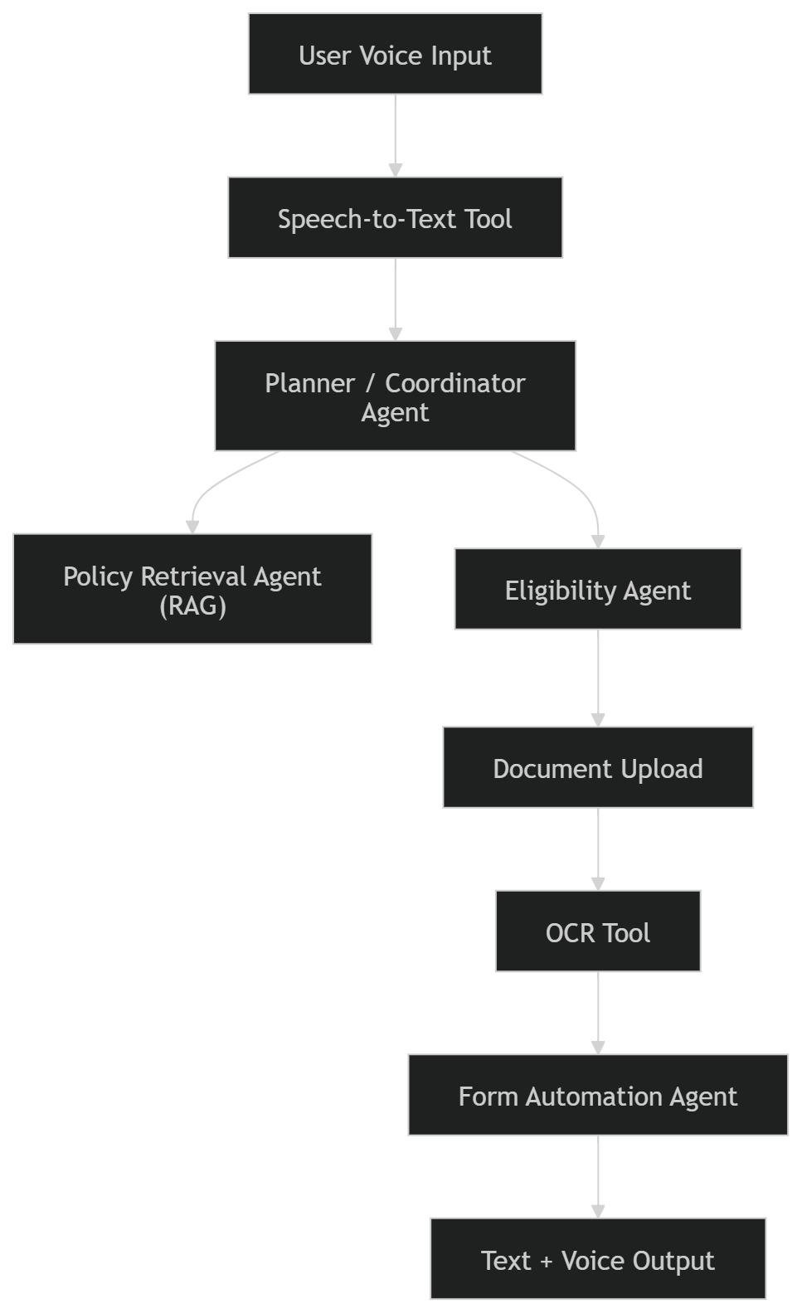

4. Proposed Technology Stack
LLM Provider
- OpenAI GPT-4 / GPT-4o (strong reasoning)
OR
- Llama 3 (cost-efficient open model)

Core Framework
- LangGraph (multi-agent orchestration)
- LlamaIndex (RAG layer)

Tools
- Whisper (Speech-to-Text)
- Indic TTS (Text-to-Speech)
- Tesseract OCR
- FAISS (Vector DB)
- FastAPI (Backend)

Memory
- ChromaDB / FAISS
- Policy document embeddings
Frontend
- React (mobile-friendly)
OR
- Streamlit (prototype)

Evaluation
- Manual rubric
- Task success rate
- Response accuracy check

Deployment
- Render / Hugging Face Spaces

5. Success Metrics & Evaluation Plan (≈ ½ page)
Quantitative Metrics
- ≥ 80% correct eligibility classification
- ≥ 85% accurate OCR extraction for Aadhaar fields
- ≤ 8 seconds response latency
- ≥ 70% successful end-to-end form generation
Test Cases:
- 20–30 simulated user scenarios

Qualitative Evaluation
- User study with 5–10 participants
- Score clarity of explanation (1–5 scale)
- Measure ease of use
- Check language simplicity

Failure Modes
- Incorrect eligibility matching
- OCR misreading
- Policy retrieval hallucination
- Slow response
Measured via structured test logs

6. Risks, Challenges & Mitigation Plan

Risk | Mitigation
Hallucinated policy info | Use strict RAG + citation
OCR errors | Ask user for re-upload
Infinite reasoning loops | Set max iteration limit
Scope creep | Limit to Karnataka schemes
API cost | Optimize prompts

7. Timeline & Milestones
By Demo 1
- Single-agent RAG prototype
- Voice input working
- Basic scheme retrieval
By Document 2
- Multi-agent workflow
- Eligibility reasoning implemented
- OCR integration
By Demo 2
- Full end-to-end flow
- 15 schemes loaded
- Evaluation metrics dashboard
Final Submission
- Polished UI
- 20+ test cases
- Performance evaluation
- Deployment live

